

Pilot Program for Willson Financial

# We are Charlie Team



This team of diverse professional backgrounds consist of:

* Alexander Zayas
* Botiwa Konan
* Caitlan Nichols
* Scott Cacal

And we hope to supply Willson Financial the software and data needed to experience continued growth





# Case Study Description

* Jake and Ned Wilson had plenty to offer their small town in New Mexico, in terms of financial management and advising
* Once they obtained their licensing they began building the company and gained new team members along the way
* Over the course of a year they have grown to a point where an analysis of the companies finances should be performed
* With the gained information they should understand how to be scalable while providing customer satisfaction



# Entity Relationship Diagram



With our analysis of the Willson Financial Case Study we have generated the following ERD

* Employees
  + EmployeeID (PK)
  + Name
  + Position
  + EmploymentType (Full-Time, Part-Time)
  + HireDate
* Clients
  + ClientID (PK)
  + Name
  + ContactInfo
  + JoinDate
  + Status (Active, Inactive)
* Assets
  + AssetID (PK)
  + ClientID (FK)
  + AssetType (e.g., Cash, Investments, Real Estate)
  + ValueValuationDate
* Transactions
  + TransactionID (PK)
  + ClientID (FK)
  + TransactionDate
  + Amount
  + Description
  + TransactionType (Credit, Debit)
* Billing
  + BillingID (PK)
  + ClientID (FK)
  + BillingDate
  + Amount
  + BillingMethod (Fixed Fee, Percentage of Assets)

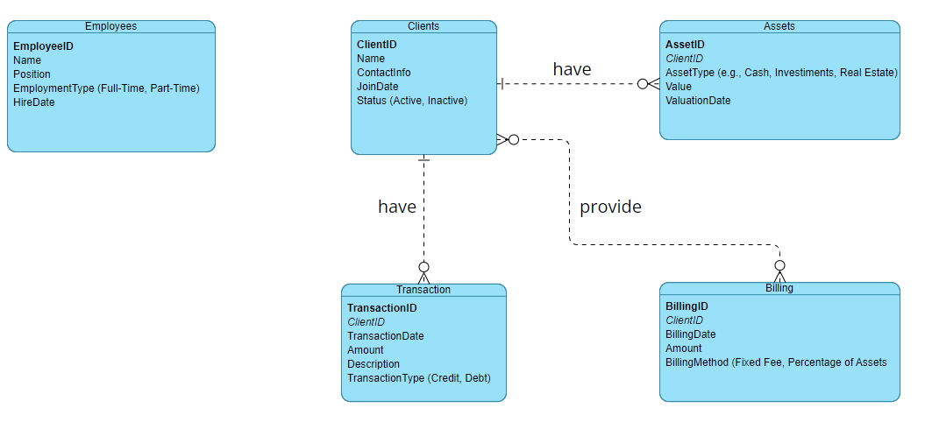

- Team Charlie ERD

# Reports



With the company's latest data we can generate the following reports:

* **Average Client Assets Report:** This script calculates the average amount of assets for the entire client list.
* **Clients with Highest Total Asset Value Report:** This script identifies clients with the highest total asset value.
* **Clients with High Transaction Volume Report:** This script needs to identify clients with more than ten transactions in the past month.
* **New Clients Added Per Month Report:** This script needs to count the number of clients added each month for the past six months.



- Average Client Assets Report

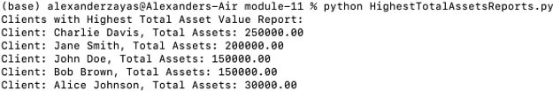

- Clients with Highest Total Assets Value Report

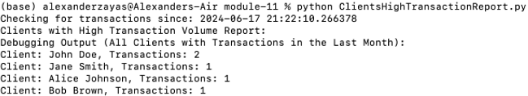

- Clients with High Transaction Volume Report



- New Clients Added Per Month Report

# Conclusion







Assumptions

Our reports directly answer some of the questions raised by Willson Financial such as clients with 10 or more transactions or the amount of clients added over the last six months. Providing a report for average amount of assets for the entire client list in addition to a report that identifies clients with the highest total asset value can offer valuable data that may guide the company to making wise financial decisions.